Tomcat

Tomcat is a application server

Whenever we build jar, war, files those want to apply in tomcat

Build – artifactory – tomcat

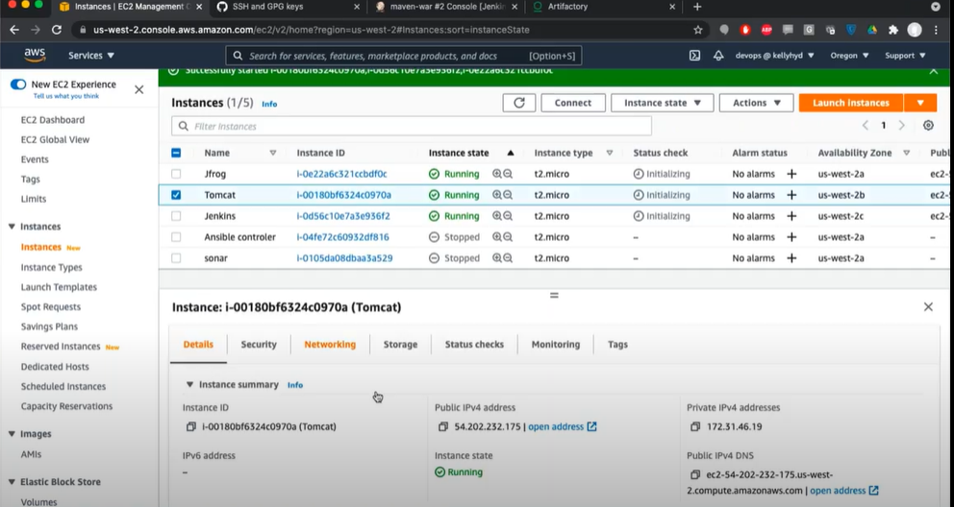

Go to AWS create EC2 server for tomcat

Copy public ip address

Go to terminal

Login terminal

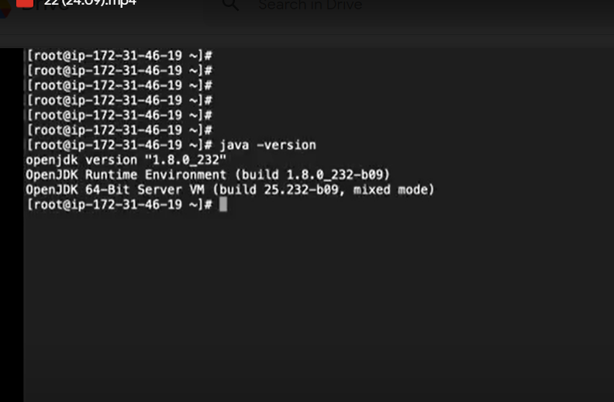

Check java is present or not

Go to browser download appache tomcat

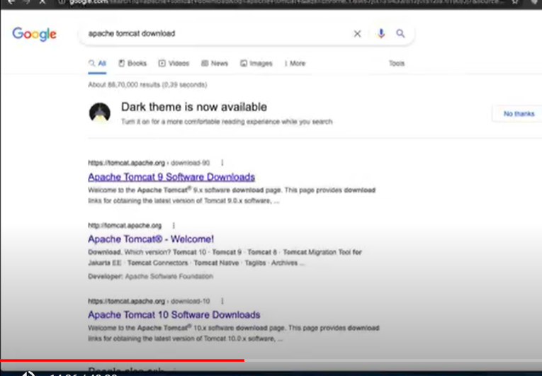

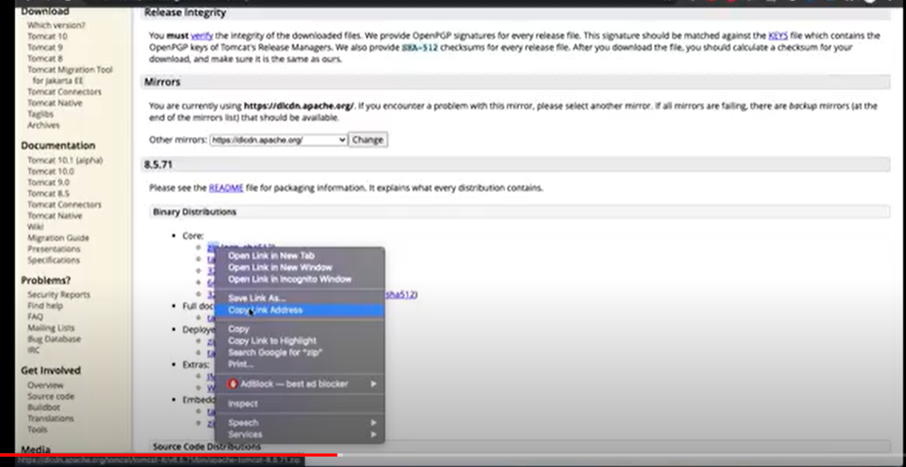

Select latest version

Go to binary distribution

Copy zip right click copy link address

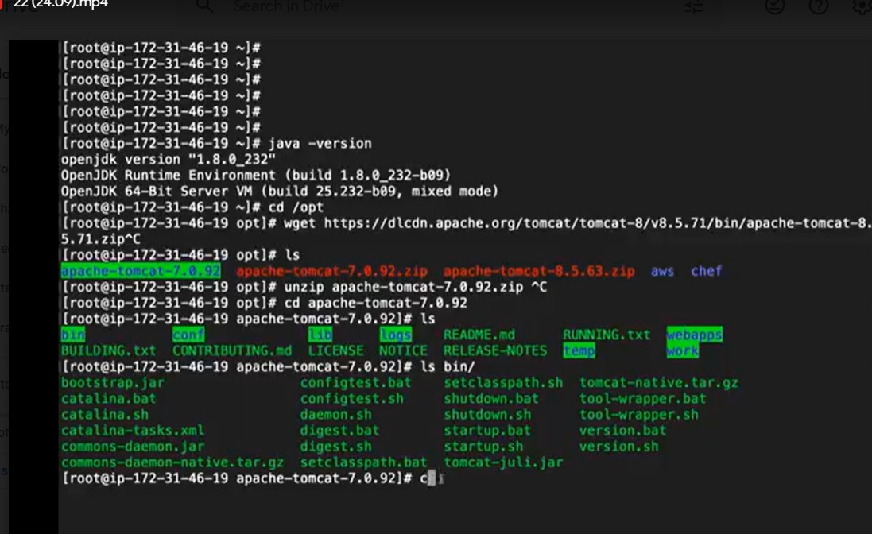

Go to terminal

#cd/opt

#wget past the zip link

#ls

# unzip “appache tomcat zip past link”

#cd appache-tocat.7.0.92

# ls

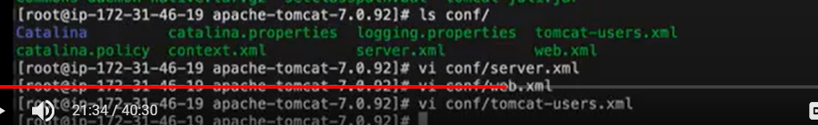

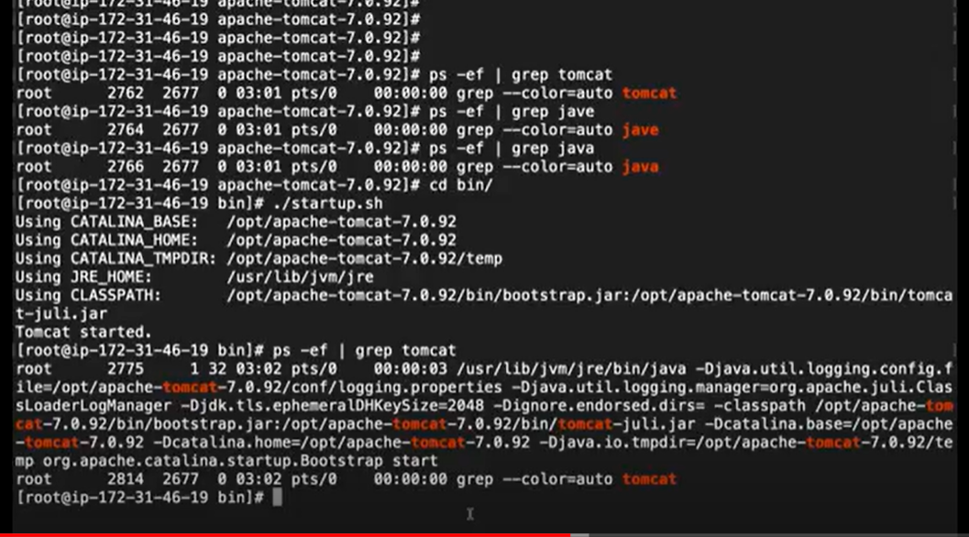

# ps -ef Igrep tomcat : checking running tomcat

#cd bin/

# ./startup.sh : running tomcat cmnd

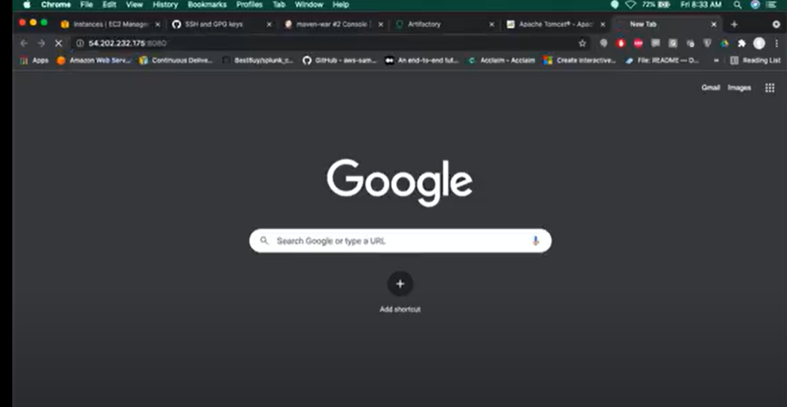

Take tomcat public ip in aws

Go to browser past and add :8080

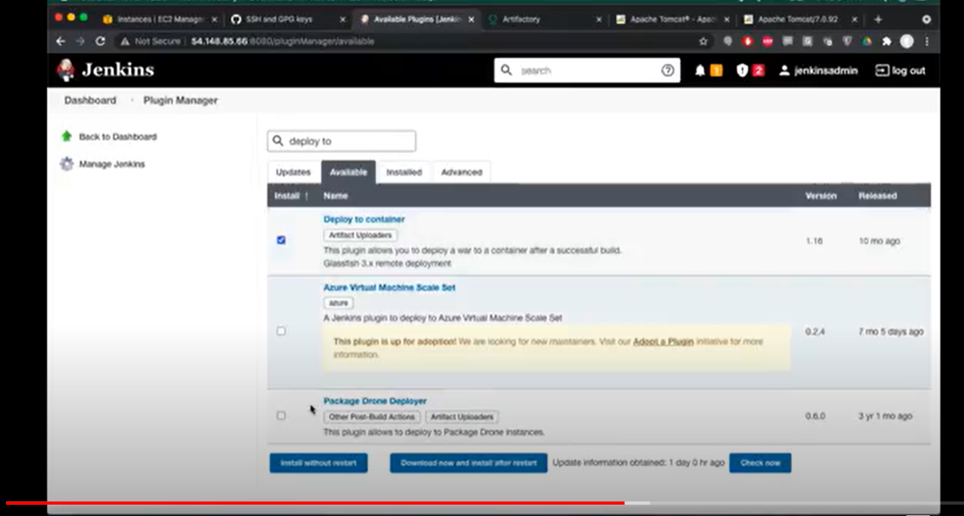

Go to Jenkins

Click on manage Jenkins

Managa plugin

Select available plugin

Deploy to container

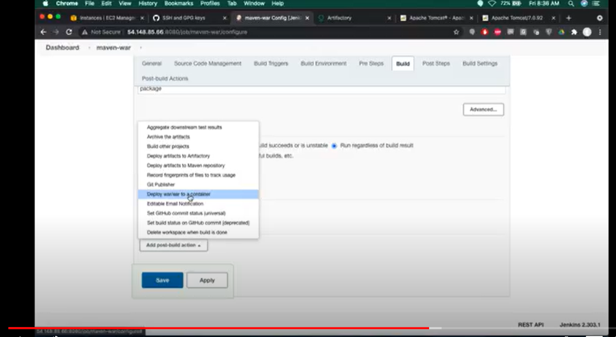

Go to dashboard

Go to the job

Go to the configuration

Click on the post build action

Select deploy war/ear to a container

Give ../..war

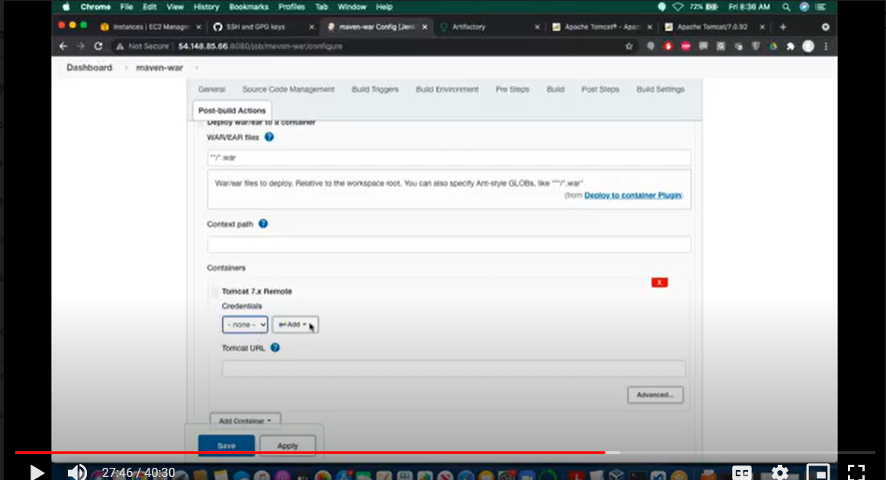

Give tomcat url

Give credential of Jenkins ex: admin psswrd :admin

Save

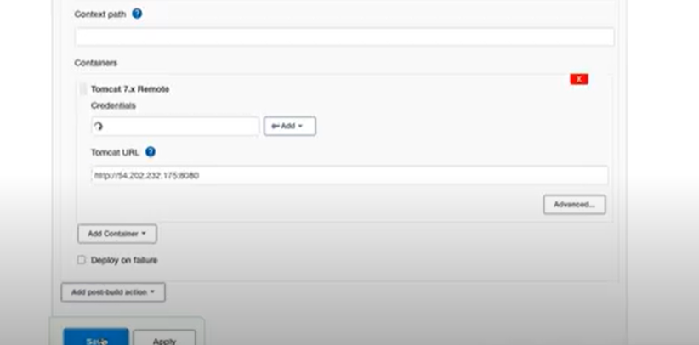

Go to tomcat server

Click host manager and give vredential

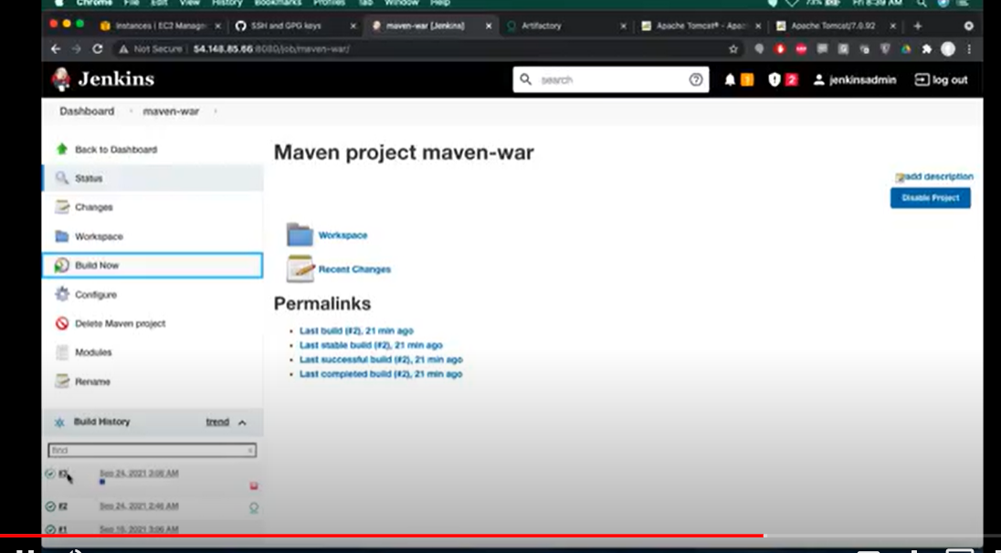

Go to jenkin site

Select file and click build now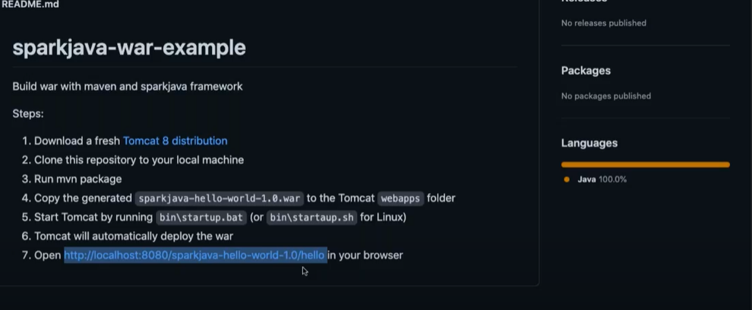

Developer will give the url copy that url and go to browser check if open site that is working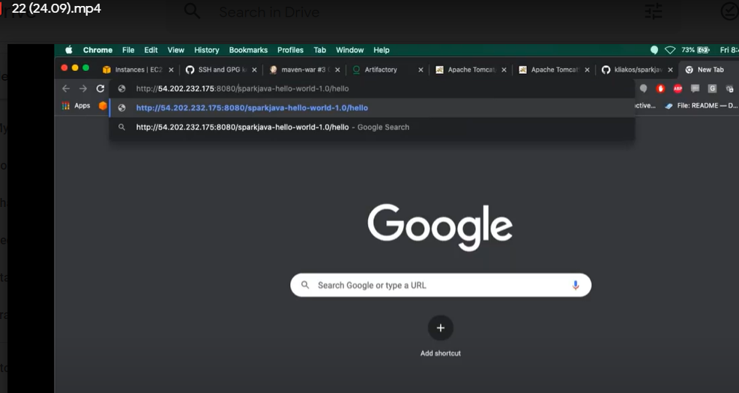

Jenkin we can use in command line also

